List of Sensors and actuator used for Smart Blind Stick

SENSOR

Ultrasonic Sensors

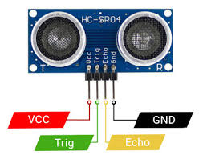

ACTUATOR

Active Buzzer

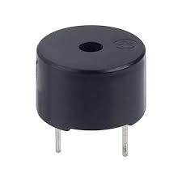

Passive Buzzer

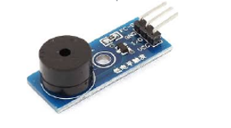

Vibration Motor

